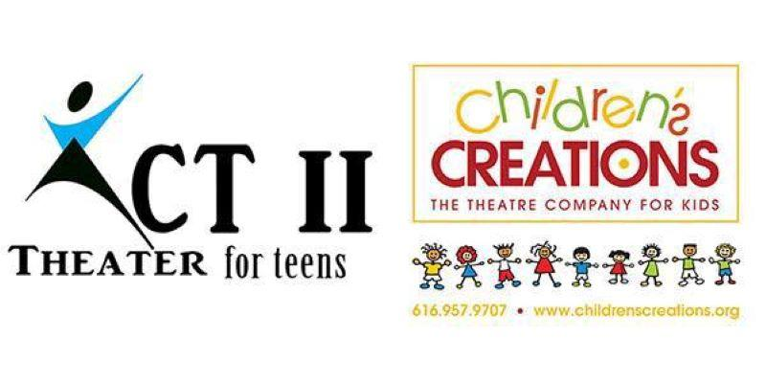
“The Boy Pinocchio”
616-957-9707
Director: Janae K. Dean
www.childrenscreations.org

- Schedule Subject to Change. Please be flexible.
- Attend as many rehearsals as possible, required to be at dress rehearsal and all performances!
- Water Only, & a Non-Messy Snack Are Allowed
- Pick up on time! READ SCHEDULE CAREFULLY: $5.00 charge every 15 minutes your late.
- All rehearsals are closed to parents, friends, etc.
- Doors at show will open ½ hour before show. No saving seats allowed until the doors open.
- Tuition is $225

Thursday, July 11th | AUDITIONS | 6:00 p.m.
Thursday, July 18th |  | 2:30 p.m. – 4:30 p.m.
Saturday, July 27th |  | 1:00 p.m. – 4:00 p.m.
Thursday, August 1st |  | 2:30 p.m. – 4:30 p.m.
Thursday, August 8th |  | 2:30 p.m. – 4:30 p.m.
Thursday, August 15th |  | 2:30 p.m. – 4:30 p.m.
Saturday, August 24th |  | 9:30 a.m. – 1:30 p.m.
Thursday, August 29th |  | 4:30 p.m. – 7:00 p.m.
Thursday, September 5th |  | 4:30 p.m. – 7:00 p.m.
Thursday, September 12th |  | 4:30 p.m. – 7:00 p.m.
Thursday, September 19th | DRESS REHEARSAL  Children’s Creations Theater  6161 28th Street SE #8 | 4:30 p.m. – 8:30 p.m.
Friday, September 20th | PERFORMANCE  Children’s Creations Theater  6161 28th Street SE #8  Grand Rapids, MI 49546 | Day Time and Evening Performances  Call time: 5:00 p.m.  Performance #1: 7:00 p.m.
Saturday, September 21st | PERFORMANCE  Children’s Creations Theater  6161 28th Street SE #8  Grand Rapids, MI 49546 | Day Time and Evening Performances  Call time: 1:00 p.m.  Performance #2: 3:00 p.m.  Performance #3: 6:00 p.m.  (Cast will stay at studio between shows)
Thursday, September 26th | Cast Party  $10.00 per person | 5:00 p.m. – 7:00 p.m.

