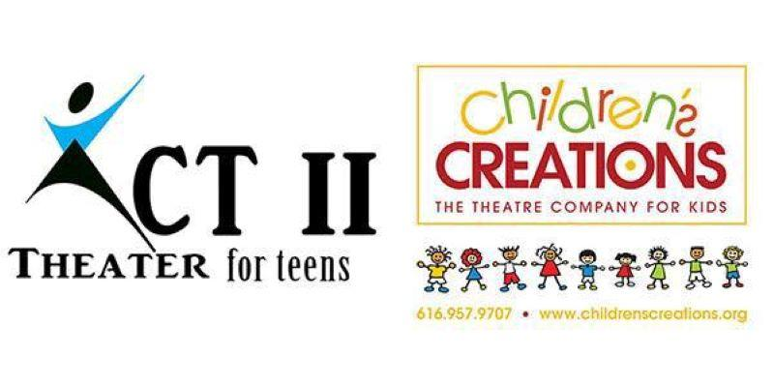
“Little House on the Prairie – The Spelling Bee”
616-957-9707
Director: Janae K. Dean
www.childrenscreations.org

- Schedule Subject to Change. Please be flexible
- Attend as many rehearsals as possible, required to be at dress rehearsal and all performances!
- Water Only, & a Non-Messy Snack Are Allowed
- Pick up on time! READ SCHEDULE CAREFULLY: $5.00 charge every 15 minutes your late.
- All rehearsals are closed to parents, friends, etc.
- Doors at show will open ½ hour before show. No saving seats allowed until the doors open.
Tuesday, August 20th | AUDITIONS | 6:00 p.m.
Tuesday, August 27th |  | 4:30 p.m. – 7:30 p.m.
Tuesday, September 3rd |  | 4:30 p.m. – 7:30 p.m.
Saturday, September 7th |  | 9:30 a.m. – 1:00 p.m.
Tuesday, September 10th |  | 4:30 p.m. – 7:30 p.m.
Saturday, September 14th |  | 9:30 a.m. – 1:00 p.m.
Tuesday, September 17th | Lines MUST be Memorized!  MANDATORY Parent Meeting  7:00 p.m. | 4:30 p.m. – 7:30 p.m.
Tuesday, September 24th |  | 4:30 p.m. – 7:30 p.m.
Tuesday, October 1st |  | 4:30 p.m. – 7:30 p.m.
Thursday, October 3rd | DRESS REHEARSAL  Children’s Creations Theater  6161 28th Street SE #8 | 4:30 p.m. – 8:30 p.m.
Friday, October 4th | PERFORMANCE  Children’s Creations Theater  6161 28th Street SE #8  Grand Rapids, MI 49546 | Day Time and Evening Performances  Call time: 8:00 a.m.  Performance #1: 9:30 a.m.  Performance #2: 11:30 a.m.  Pick up Time: 1:00 p.m.  PM Call time: 5:30 p.m.  Performance #3: 7:00 p.m.
Saturday, October 5th | PERFORMANCE  Children’s Creations Theater  6161 28th Street SE #8  Grand Rapids, MI 49546 | Day Time and Evening Performances  Call time: 10:00 a.m.  Performance #4 12:00 p.m.  Performance #5: 3:00 p.m.  Performance #6: 6:00 p.m.  (Cast will stay at studio between shows)
Tuesday, October 8th | Cast Party  $10.00 per person | 4:30 p.m. – 6:30 p.m.

