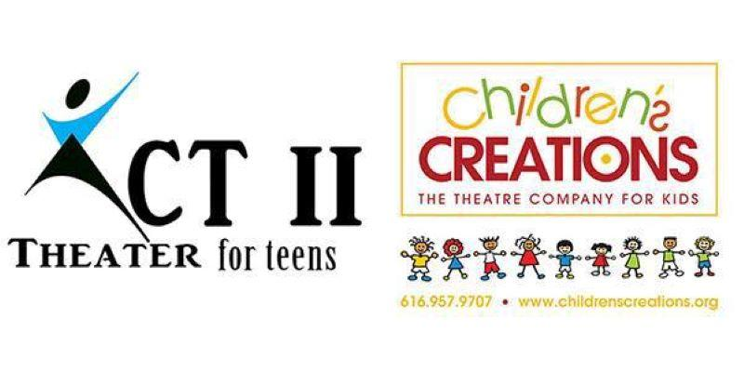
“The Jungle Book”
616-957-9707
Director: Janae K. Dean
www.childrenscreations.org

- Schedule Subject to Change. Please be flexible.
- Attend as many rehearsals as possible, required to be at dress rehearsal and all performances!
- Water Only, & a Non-Messy Snack Are Allowed
- Pick up on time! READ SCHEDULE CAREFULLY: $5.00 charge every 15 minutes your late.
- All rehearsals are closed to parents, friends, etc.
- Doors at show will open ½ hour before show. No saving seats allowed until the doors open.
- Tuition is $225

Monday, June 24th | AUDITIONS | 6:00 p.m.
Monday, July 1st |  | 4:30 p.m. – 7:30 p.m.
Monday, July 8th |  | 4:30 p.m. – 7:30 p.m.
Monday, July 15th |  | 4:30 p.m. – 7:30 p.m.
Monday, July 22nd | Lines MUST be Memorized!  MANDATORY Parent Meeting  7:00 p.m. | 4:30 p.m. – 7:30 p.m.
Monday, July 29th |  | 4:30 p.m. – 7:30 p.m.
Monday, August 5th |  | 4:30 p.m. – 7:30 p.m.
Saturday, August 10th |  | 9:30 a.m. – 1:30 p.m.
Monday, August 12th |  | 4:30 p.m. – 7:30 p.m.
Thursday, August 15th | DRESS REHEARSAL  Children’s Creations Theater  6161 28th Street SE #8 | 4:30 p.m. – 8:30 p.m.
Friday, August 16th | PERFORMANCE  Children’s Creations Theater  6161 28th Street SE #8  Grand Rapids, MI 49546 | Day Time and Evening Performances  Call time: 1:00 p.m.  Performance #1: 3:00 p.m.  Performance #2: 6:00 p.m.  (Cast will stay at studio between shows)
Saturday, August 17th | PERFORMANCE  Children’s Creations Theater  6161 28th Street SE #8  Grand Rapids, MI 49546 | Day Time and Evening Performances  Call time: 10:00 a.m.  Performance #3 12:00 p.m.  Performance #4: 3:00 p.m.  Performance #5: 6:00 p.m.  (Cast will stay at studio between shows)
Monday, August 19th | Cast Party  $10.00 per person | 5:00 p.m. – 7:00 p.m.

