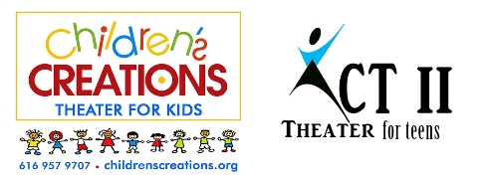
“Lion King Jr.”
616-957-9707
Director: Janae K. Dean
www.childrenscreations.org

- Schedule Subject to Change. Please be flexible.
- Attend as many rehearsals as possible, all cast members are required to be at dress rehearsal and all performances!
- Only Water and Non-Messy Snacks Are Allowed
- Pick up on time! READ SCHEDULE CAREFULLY: $5.00 charge every 15 minutes you’re late.
- All rehearsals are closed to parents, friends, etc.
- Doors at show will open ½ hour before show. No saving seats allowed until the doors open.
- Tuition for this show will be $225 per student.
Continued page 2
Tuesday, April 16th | AUDITIONS | 6:00 p.m.
Tuesday, April 23rd |  | 4:30 p.m. – 7:30 p.m.
Tuesday, April 30th |  | 4:30 p.m. – 7:30 p.m.
Thursday, May 2nd |  | 4:30 p.m. – 7:30 p.m.
Saturday, May 4th |  | 9:30 a.m. – 1:30 p.m.
Tuesday, May 7th |  | 4:30 p.m. – 7:30 p.m.
Thursday, May 9th |  | 4:30 p.m. – 7:30 p.m.
Saturday, May 11th |  | 9:30 a.m. - 1:30 p.m.
Tuesday, May 14th |  | 4:30 p.m. – 7:30 p.m.
Thursday, May 16th |  | 4:30 p.m. - 7:30 p.m.
Tuesday May 21st | MANDATORY Parent Meeting  7:15 p.m. | 4:30 p.m. – 7:30 p.m.
Thursday, May 23rd |  | 4:30 p.m. – 7:30 p.m.
Tuesday, May 28th |  | 4:30 p.m. – 7:30 p.m.
Thursday, May 30th |  | 4:30 p.m. – 7:30 p.m.
Saturday, June 1st |  | 9:30 a.m. – 1:30 p.m.
Tuesday, June 4th |  | 4:30 p.m. – 7:30 p.m.
Thursday, June 6th |  | 4:30 p.m. – 7:30 p.m.
Saturday, June 8th |  | 9:30 a.m. - 1:30 p.m.
Wednesday, June 12th | DRESS REHEARSAL  East Grand Rapids Performing Arts Center  2211 Lake Drive SE  East Grand Rapids, MI 49506 | 4:30 p.m. – 8:30 p.m.
Thursday, June 13th | PERFORMANCE  East Grand Rapids Performing Arts Center  2211 Lake Drive SE  East Grand Rapids, MI 49506 | Call Time: 1:30 p.m.  Performance #1 3:00 p.m.  Performance #2 6:00 p.m.

