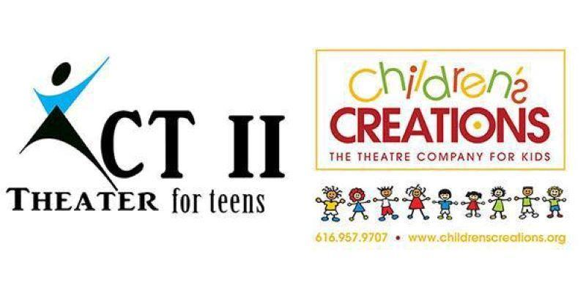
“Two Nights Before Christmas”
616-957-9707
Director: Janae K. Dean
www.childrenscreations.org

- Schedule Subject to Change. Please be flexible.
- Attend as many rehearsals as possible, required to be at dress rehearsal and all performances!
- Water Only, & a Non-Messy Snack Are Allowed
- Pick up on time! READ SCHEDULE CAREFULLY: $5.00 charge every 15 minutes your late.
- All rehearsals are closed to parents, friends, etc.
- Doors at show will open ½ hour before show. No saving seats allowed until the doors open.
- Please sell all of the tickets in your packets and attend the parent meeting to pick up your ticket packet.

Monday, October 23rd | AUDITIONS | 6:00 p.m.
Monday, October 30th |  | 4:30 p.m. – 6:30 p.m.
Saturday, November 4th |  | 9:30 a.m. – 1:00 p.m.
Monday, November 6th |  | 4:30 p.m. – 6:30 p.m.
Monday, November 13th |  | 4:30 p.m. – 6:30 p.m.
Monday, November 20th | MANDATORY Parent Meeting  6:30 PM | 4:30 p.m. – 6:30 p.m.
Monday, November 27th | Lines MUST be Memorized! | 4:30 p.m. – 6:30 p.m.
Monday, December 4th |  | 4:30 p.m. – 6:30 p.m.
Wednesday, December 13th | DRESS REHEARSAL  Children’s Creations Theater  616128th Street SE #8  Grand Rapids, MI 49546 | 4:30 – 8:30 p.m.  ALL CAST
Thursday, December 14th | PERFORMANCE  Children’s Creations Theater  616128th Street SE #8  Grand Rapids, MI 49546 | 6:00 PM Evening Performance  Call Time: 4:00 p.m.  Doors Open: 5:30 p.m.  Performance 6:00 p.m.
Friday, December 15th | PERFORMANCE  Children’s Creations Theater  616128th Street SE #8  Grand Rapids, MI 49546 | 6:00 PM Evening Performance  Call Time: 4:00 p.m.  Doors Open: 5:30 p.m.  Performance 6:00 p.m.

