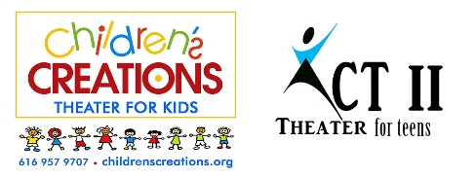
“Seussical the Musical Jr.” 2023
616-957-9707
Director: Janae K. Dean
www.childrenscreations.org

- Schedule Subject to Change. Please be flexible.
- Attend as many rehearsals as possible, all cast members are required to be at dress rehearsal and all performances!
- Only Water and Non-Messy Snacks Are Allowed
- Pick up on time! READ SCHEDULE CAREFULLY: $5.00 charge every 15 minutes your late.
- All rehearsals are closed to parents, friends, etc.
- Doors at show will open ½ hour before show. No saving seats allowed until the doors open.
- Tuition for this show will be $225 per student.

Tuesday, February 21st | AUDITIONS | 6:00 p.m.
Thursday, February 23rd |  | 4:30 p.m. – 7:30 p.m.
Tuesday, February 28th |  | 4:30 p.m. – 7:30 p.m.
Saturday, March 4th |  | 9:30 a.m. – 1:00 p.m.
Tuesday, March 7th | Lines MUST be Memorized! MANDATORY Parent Meeting  7:00 p.m. | 4:30 p.m. – 7:30 p.m.
Thursday, March 16th |  | 4:30 p.m. – 7:30 p.m.
Tuesday, March 21st |  | 4:30 p.m. – 7:30 p.m.
Tuesday, March 28th |  | 4:30 p.m. – 7:30 p.m.
Thursday, March 30th |  | 4:30 p.m. – 7:30 p.m.
Tuesday, April 11th |  | 4:30 p.m. – 7:30 p.m.
Thursday, April 13th | DRESS REHEARSAL  Children’s Creations Theater  6161 28th Street SE #8 | 4:30 – 8:30 p.m.  ALL CAST
Friday, April 14th | PERFORMANCE  Children’s Creations Theater  6161 28th Street SE #8  Grand Rapids, MI 49546 | School Performances  Call Time: 8:30 a.m.  Doors Open: 9:30 a.m.  School Performance #1: 10 a.m.  School Performance #2: 12:30 p.m.  Pick up time: 2:00 p.m.  Evening Performance  Call Time: 5:30 p.m.  Doors Open: 6:30 p.m.  Evening Show: 7:00 p.m.
Saturday, April 15th | PERFORMANCE  Children’s Creations Theater  6161 28th Street SE #8  Grand Rapids, MI 49546 | Day Time and Evening Performances  Call Time: 1:30 p.m.  Doors Open: 2:30 p.m.  Performance #1: 3:00 p.m.  Performance #2: 7:00 p.m.  (Cast will stay at studio between shows)
Sunday, April 16th | PERFORMANCE  Children’s Creations Theater  6161 28th Street SE #8  Grand Rapids, MI 49546 | Day Time and Evening Performances  Call Time: 1:30 p.m.  Doors Open: 2:30 p.m.  Performance: 3:00 p.m.

